-----A virtual machine (VM) is a software-based computer that runs within a physical computer, essentially creating a separate, isolated environment with its own operating system and resources (like CPU, memory, storage) that can run applications independently, even if it's a different operating system than the host machine; for example, you could run a Windows VM on a Mac computer to access Windows programs without needing a separate Windows PC 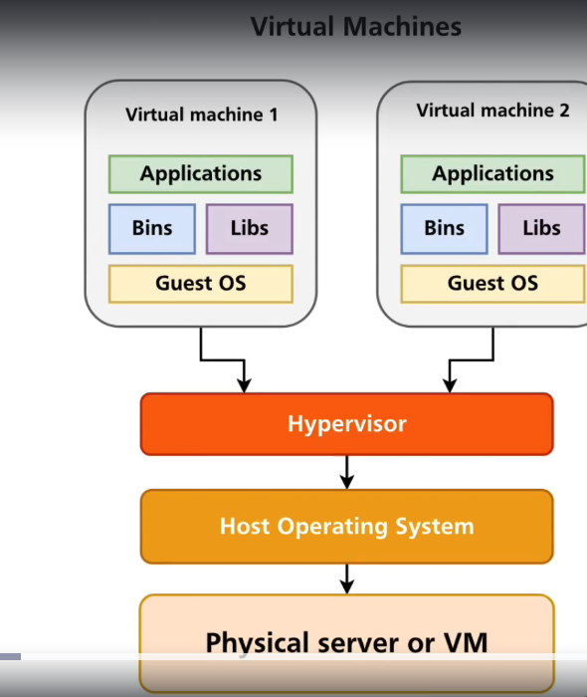

Key points about virtual machines:
- Virtualization software:
A special program called a hypervisor manages the allocation of resources from the physical host machine to the virtual machines running on it.
- Isolation:
Each virtual machine is isolated from other VMs on the same host, meaning issues on one VM won't affect the others.
- Flexibility:
You can easily create, delete, and configure VMs to meet your specific needs.
Hypervisor
Generally speaking, a hypervisor is the software layer that manages and initializes virtual machines. It manages the resources between the VM and the physical machine.
There are two different types of hypervisors:
- Type 1 hypervisors sit on top of bare metal and run off the server itself. They usually have direct access to the server's resources.
- Type 2 hypervisors are generally installed on a host operating system. They do not have full control of the computer’s resources and are instead managed by the host operating system.
Docker is an open-source platform that allows developers to package applications and their dependencies into self-contained units called "containers," which can be easily deployed and run on any system with Docker installed.
Docker and virtual machines (VMs) are two technologies used in application deployment. In the software development lifecycle, deployment prepares the application code to run for your end users. Docker is an open-source platform that developers use to package software into standardized units called containers. The container has both the application code and its environment, including libraries, system tools, and runtime. Using Docker, you can deploy and scale applications on any machine and ensure your code runs consistently. In contrast, a virtual machine is a digital copy of a physical machine. You can have multiple virtual machines with their own individual operating systems running on the same host operating system. Developers configure the virtual machine to create the application’s environment. It’s also possible to run Docker containers on virtual machines.
Virtualization allows the creation of a virtual instance of real-life resources, such as servers and networks. In computing, virtualization allows multiple isolated instances of a virtualized component to operate on the real-life component.
For example, multiple virtual servers could run on a physical server. By sharing real-life resources among multiple virtual instances, they’re better utilized and more cost-effective to run. Virtualization is the basis of a significant amount of application development and deployment.
Virtual machines
As the name suggests, virtual machines (VMs) provide virtualization of an entire machine (server). A virtual machine emulates the hardware components of a physical machine, such as the CPU, memory, network interface card, USB controllers, and sound cards. You can run a guest operating system and multiple applications in the virtual environment.
Virtual machines have made cloud technologies possible, and in Amazon Web Services (AWS), a virtual machine is called an instance. These cloud instances are owned and maintained by AWS and usable via APIs.

Key differences: Docker vs. virtual machine
Both virtual machines (VMs) and Docker address the challenge of running applications across different environments. But they do so for slightly different reasons and with different approaches.
Objective
Virtual machines were originally designed to allow multiple operating systems to run on a single physical machine. The objective is to allow users to create a virtual environment that’s isolated from the underlying hardware. VMs abstract hardware details to make it easier to run applications on different hardware architectures and use hardware resources more efficiently.
Docker, on the other hand, was designed to provide a lightweight and portable way to package and run applications in an isolated and reproducible environment. Docker abstracts operating system details to address the challenge of deploying applications across different environments, such as development, testing, and production. It can be very challenging to manage software environment updates and maintain environment consistency everywhere. This is especially true for organizations that run hundreds of applications or decompose applications into hundreds of microservices. Docker addresses this problem through containerization.
End product
Docker is the name of the open-source container platform that’s owned and operated by the company Docker. There are alternative platforms like Podman, although they’re far less popular; Docker is synonymous with containerization. The container is the artifact, the usable part for the end user.
A virtual machine itself is the usable part for the end user. The technology isn’t associated with a specific brand. You can deploy VMs in on-premises data centers or access them via APIs as a managed cloud service.
Architecture
A virtual machine runs its own kernel and host operating system, along with applications and their dependencies like libraries and other binary files. A hypervisor coordinates between the hardware (host machine or server) and the virtual machine. It allocates the physical hardware resources outlined during instantiation to the virtual machine for its exclusive use. Multiple virtual machines can exist on a single powerful server, managed by a single hypervisor, with hundreds of applications running on each virtual machine.
A Docker container contains only its dependencies. The software Docker Engine powers virtualization in Docker. It provides coordination between running containers and the underlying operating system, whether it’s a physical or virtual machine.

Containers and virtual machines are very similar resource virtualization technologies. Virtualization is the process in which a system singular resource like RAM, CPU, Disk, or Networking can be ‘virtualized’ and represented as multiple resources. The key differentiator between containers and virtual machines is that virtual machines virtualize an entire machine down to the hardware layers and containers only virtualize software layers above the operating system level.
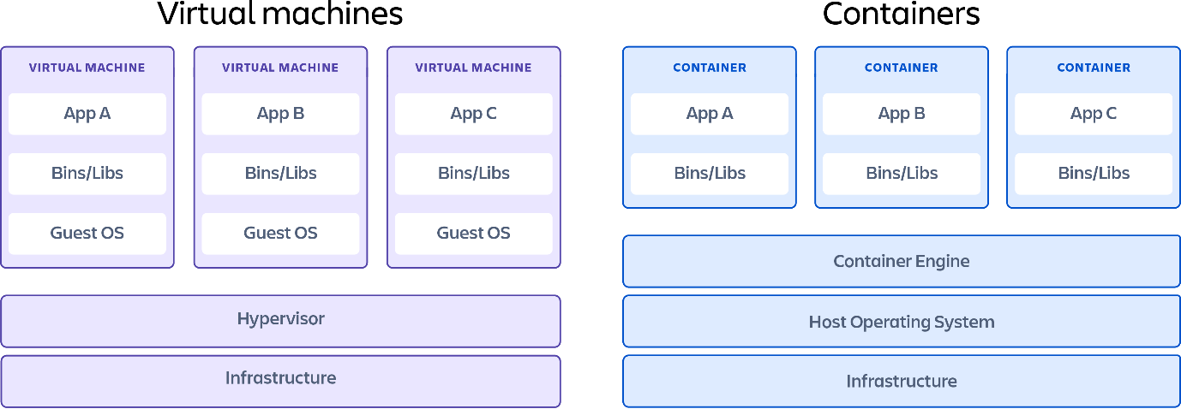
What is a container?

Containers are lightweight software packages that contain all the dependencies required to execute the contained software application. These dependencies include things like system libraries, external third-party code packages, and other operating system level applications. The dependencies included in a container exist in stack levels that are higher than the operating system.
Pros
- Iteration speed
Because containers are lightweight and only include high level software, they are very fast to modify and iterate on.
- Robust ecosystem
Most container runtime systems offer a hosted public repository of pre-made containers. These container repositories contain many popular software applications like databases or messaging systems and can be instantly downloaded and executed, saving time for development teams
Cons
- Shared host exploits
Containers all share the same underlying hardware system below the operating system layer, it is possible that an exploit in one container could break out of the container and affect the shared hardware. Most popular container runtimes have public repositories of pre-built containers. There is a security risk in using one of these public images as they may contain exploits or may be vulnerable to being hijacked by nefarious actors.
What is a virtual machine?

Virtual machines are heavy software packages that provide complete emulation of low level hardware devices like CPU, Disk and Networking devices. Virtual machines may also include a complementary software stack to run on the emulated hardware. These hardware and software packages combined produce a fully functional snapshot of a computational system.
Pros
- Full isolation security
Virtual machines run in isolation as a fully standalone system. This means that virtual machines are immune to any exploits or interference from other virtual machines on a shared host. An individual virtual machine can still be hijacked by an exploit but the exploited virtual machine will be isolated and unable to contaminate any other neighboring virtual machines.
- Interactive development
Containers are usually static definitions of the expected dependencies and configuration needed to run the container. Virtual machines are more dynamic and can be interactively developed. Once the basic hardware definition is specified for a virtual machine the virtual machine can then be treated as a bare bones computer. Software can manually be installed to the virtual machine and the virtual machine can be snapshotted to capture the current configuration state. The virtual machine snapshots can be used to restore the virtual machine to that point in time or spin up additional virtual machines with that configuration.
Cons
- Iteration speed
Virtual machines are time consuming to build and regenerate because they encompass a full stack system. Any modifications to a virtual machine snapshot can take significant time to regenerate and validate they behave as expected.
- Storage size cost
Virtual machines can take up a lot of storage space. They can quickly grow to several gigabytes in size. This can lead to disk space shortage issues on the virtual machines host machine.
Popular virtual machine providers
- Virtualbox
Virtualbox is a free and open source x86 architecture emulation system owned by Oracle. Virtualbox is one of the most popular and established virtual machine platforms with an ecosystem of supplementary tools to help develop and distribute virtual machine images.
- VMware
VMware is a publicly traded company that has built its business on one of the first x86 hardware virtualization technologies. VMware comes included with a hypervisor which is a utility that will deploy and manage multiple virtual machines. VMware has robust UI for managing virtual machines. VMware is a great enterprise virtual machine option offering support.
- QEMU
QEUM is the most robust hardware emulation virtual machine option. It has support for any generic hardware architecture. QEMU is a command line only utility and does not offer a graphical user interface for configuration or execution. This trade-off makes QEMU one of the fastest virtual machine options.
Which option is better for you?

If you have specific hardware requirements for your project, or you are developing on one hardware platform and need to target another like Windows vs MacOS, you will need to use a virtual machine. Most other 'software only' requirements can be met by using containers.
How can you use containers and virtual machines together?

It is entirely possible to use containers and virtual machines in unison although the practical use-cases may be limited. A virtual machine can be created that emulates a unique hardware configuration. An operating system can then be installed within this virtual machine's hardware. Once the virtual machine is functional and boots the operating system, a container runtime can be installed on the operating system. At this point we have a functional computational system with emulated hardware that we can install containers on.
One practical use for this configuration is experimentation for system on chip deployments. Popular system on chip computational devices like the Raspberry Pi, or BeagleBone development boards can be emulated as a virtual machine, to experiment with running containers on them before testing on the actual hardware.
But the majority of the time, your needs will likely be met by one of the two. The key to deciding between containers or virtual machines for your virtualization needs is understanding your resource needs and the trade-offs you’re willing to make.

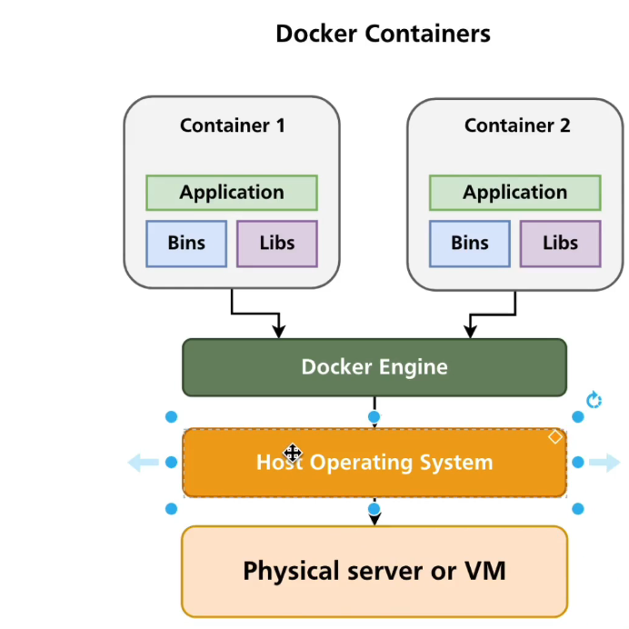

Docker Engine
The Docker Engine (DE) is installed on the host machine and represents the core of the Docker system. It is a lightweight runtime system and the underlying client-server technology that creates and manages containers.
Docker Engine consists of three components:
- Server — the Docker daemon (dockerd), which is responsible for creating and managing containers.
- Rest API — establishes communication between programs and Docker and instructs dockerd what to do.
- Command Line Interface (CLI) — used for running Docker commands.
Docker Objects:
Docker Images: Docker Containers, Volumes: Networks:
Docker Daemon in Detail
The Docker Daemon is responsible for building, running, and distributing Docker containers. The Daemon listens for API requests and then processes certain commands to create or manage containers and images. This functionality allows developers to deploy applications in isolated environments, making it easier to manage dependencies and configurations. The Daemon can also communicate with other Daemons in a distributed system, facilitating orchestration tasks across multiple hosts.
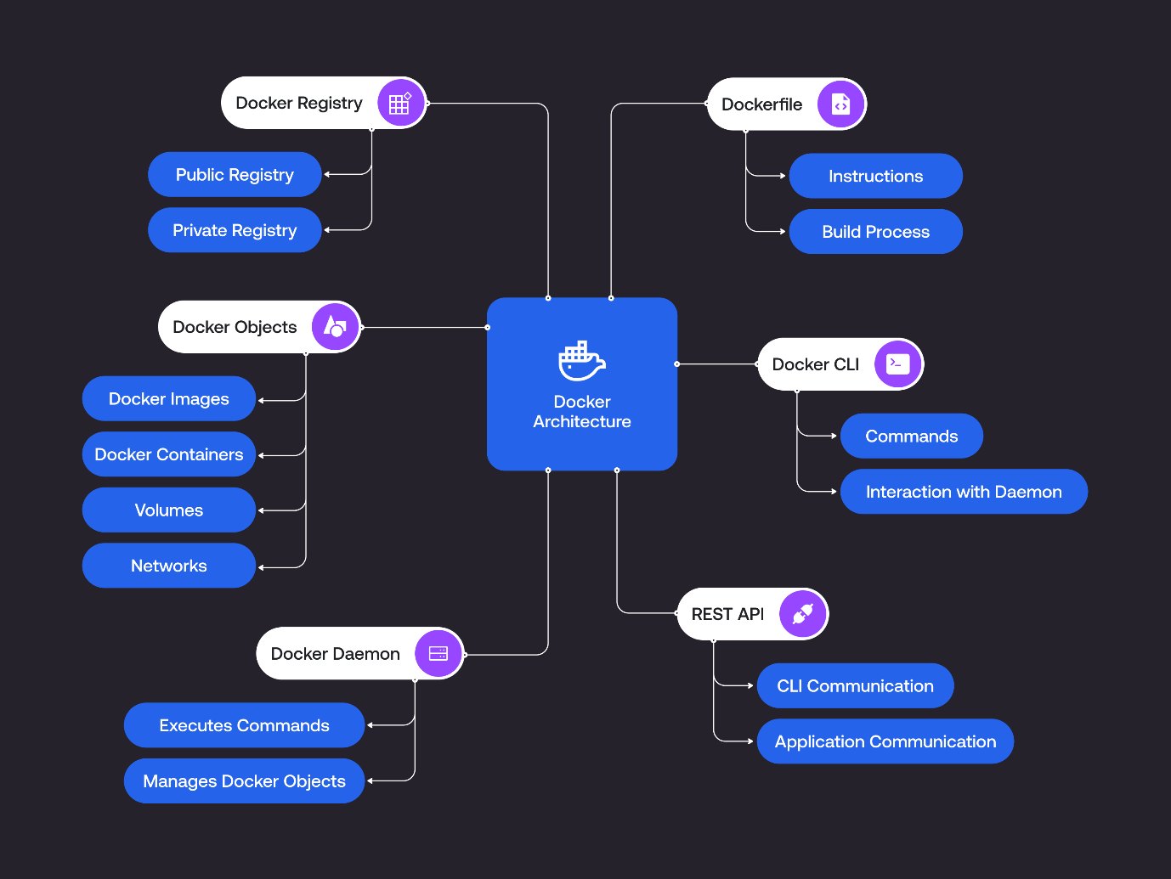
docker run -d --name hello-world
But what exactly is happening internally?
- Command Reception: The Docker client sends a request to the Docker Daemon via the Docker API to run a new container.
- Image Check: The Daemon checks if the hello-world image is available locally. If not, it initiates a pull request to the configured Docker registry (default is Docker Hub).
- Image Pulling: If the image is not found locally, the Daemon communicates with the registry to download the image layers. Each layer is stored in the Docker storage directory (e.g., /var/lib/docker).
- Container Creation: The Daemon creates a new container instance from the image. It sets up the filesystem, environment variables, and configurations specified in the image.
- Network Setup: The Daemon assigns a network interface to the container, allowing it to communicate with other containers and the host.
- Process Initialization: The Daemon starts the container process in a new namespace, isolating it from other processes on the host. This includes setting up PID, network, and IPC namespaces.
- Detached Mode: Since d is specified, the container runs in detached mode, allowing it to operate in the background.
- State Management: The Daemon updates the container's state to "running" and monitors its health and resource usage.
docker build -t sample_image:latest
This command builds a Docker image from a Dockerfile located in the current directory (denoted by .) and tags it as sample_image:latest
But what happens internally?
- Command Reception: When the docker build command is executed, the Docker client sends a request to the Docker Daemon via the Docker API to initiate the build process.
- Dockerfile Parsing: The Daemon retrieves the Dockerfile from the specified context (in this case, the current directory). It parses the Dockerfile to understand the instructions provided, such as FROM, RUN, COPY, and CMD.
- Base Image Retrieval: If the Dockerfile specifies a base image (e.g., FROM ubuntu), the Daemon checks if this base image is available locally. If it is not found, the Daemon pulls it from the Docker registry, following the process outlined in the previous section (checking the registry, downloading layers, etc.).
- Layer Creation: As the Daemon processes each instruction in the Dockerfile, it creates a new layer for each command. For example:
  - RUN: Executes commands in a new layer and commits the changes.
  - COPY: Copies files from the host into the image, creating another layer.
  - ENV: Sets environment variables, which also results in a new layer.
- Layer Storage: Each layer created during the build process is stored in the Docker storage directory (e.g., /var/lib/docker). Docker uses a union filesystem (like OverlayFS) to manage these layers, allowing for efficient storage and retrieval. This approach is necessary because it minimizes duplication of data and enables quick access to the layers that make up an image. By stacking layers, Docker can efficiently manage changes and updates, saving both disk space and time during builds.
- Image Metadata Update: After processing all instructions in the Dockerfile, the Daemon updates its internal metadata to reflect the new image, including its layers, tags, and configurations.
- Completion Notification: Finally, the Docker Daemon sends a message back to the Docker client, confirming that the image has been successfully built and is available for use.
- Pulling an Image
- Now, let’s revisit the docker pull command:
- docker pull ubuntu
But here is internal process that takes place:
- Command Reception: When the docker pull ubuntu command is executed, the Docker client sends a request to the Docker Daemon via the Docker API to retrieve the ubuntu image from a Docker registry.
- Registry Communication: The Daemon checks if the requested image is available locally. If it is not found, it initiates communication with the Docker registry to fetch the image manifest, which contains metadata about the image layers.
- Image Manifest Retrieval: The Daemon receives the image manifest from the registry, detailing the layers that make up the image, including their digests (unique identifiers) and sizes.
- Layer Downloading: The Daemon starts downloading the required layers of the image one by one. Each layer is stored in the Docker storage directory (e.g., /var/lib/docker). The layers are downloaded using HTTP requests, and the Daemon manages the progress and integrity of each layer by verifying checksums.
- Layer Storage: Once downloaded, the layers are stored in a layered filesystem. Docker uses a union filesystem to combine these layers into a single image. Each layer is read-only, and changes made by containers based on this image are stored in a new, writable layer on top.
- Image Metadata Update: After all layers are successfully downloaded and stored, the Docker Daemon updates its internal metadata to reflect the newly pulled image, including its name, tags, and layer information.
- Completion Notification: Finally, the Docker Daemon sends a completion message back to the Docker client, confirming that the ubuntu image has been successfully pulled and is now available for use.
Both the docker build and docker pull commands involve intricate processes managed by the Docker Daemon. When building an image, the Daemon parses the Dockerfile, retrieves any necessary base images, creates layers based on the specified instructions, and updates its metadata. In contrast, when pulling an image, the Daemon communicates with the Docker registry, downloads the required layers, and stores them in the local storage directory.

Networks:
Docker supports several network types, each tailored for specific use cases. The Docker Daemon is responsible for managing these network types and ensuring proper communication between containers and the host system.
Bridge Network
The bridge network is the default network type in Docker. When a container is created without specifying a network, it is automatically attached to the bridge network. The Docker Daemon performs the following steps when creating and managing a bridge network for example when you run a command following thing are conducted by docker daemon:
docker run -d --name web --network bridge nginx
- Network Creation: The Daemon creates a Linux bridge interface (e.g., docker0) on the host system.
- IP Address Assignment: The Daemon assigns an IP address range (e.g., 172.17.0.0/16) to the bridge interface.
- Iptables Configuration: The Daemon sets up iptables rules to enable communication between containers on the bridge network and the host system.
- Container Attachment: When a container is created and attached to the bridge network, the Daemon creates a virtual Ethernet pair (veth) interface. One end of the veth pair is attached to the container's network namespace, while the other end is attached to the docker0 bridge on the host.
- IP Address Allocation: The Daemon allocates an IP address from the bridge network's IP range and assigns it to the container's network interface.
- DNS Configuration: The Daemon configures the container's DNS settings, allowing it to resolve names of other containers on the same network.
The bridge driver is used for creating bridge networks. It creates a Linux bridge interface on the host system and manages the IP address range for the network. The bridge driver is responsible for creating veth pair interfaces for containers and attaching them to the docker0 bridge.
Host Network
‍The host network mode allows a container to use the host system's network stack directly, bypassing Docker's network isolation. The Docker Daemon performs the following steps when running a container in host mode:
- Network Namespace: The Daemon does not create a separate network namespace for the container.
- Port Mapping: The Daemon does not perform any port mapping, as the container directly uses the host's network interfaces and ports.
- Network Configuration: The container inherits the host system's network configuration, including IP addresses, routes, and iptables rules.
The host driver is used for running containers in host network mode. It does not create any additional network interfaces or perform any network isolation, as the container directly uses the host system's network stack.
Overlay Network
‍The overlay network is used for multi-host networking in Docker Swarm. Docker Swarm is a built-in clustering and orchestration tool for managing multiple Docker hosts. It enables you to group several Docker Engines into a single virtual entity, allowing containers to communicate across different hosts while ensuring high availability and load balancing. This is very similar to Kubernetes. However, the fundamental difference between Docker Swarm and Kubernetes is the architecture and scalability.
Docker Swarm uses a simpler architecture and scaling method, relying on a swarm of nodes that can be easily added or removed, making it straightforward to set up and manage. This simplicity makes Docker Swarm an ideal choice for smaller projects and teams. In contrast, Kubernetes employs a more complex architecture that offers advanced features such as pod replication, self-healing, and automatic rollouts and rollbacks. It is better suited for larger and more complex applications that require the management of stateful workloads, like databases, which need unique network configurations.
An overlay network allows containers on different Docker hosts to communicate securely. The Docker Daemon performs the following steps when creating and managing an overlay network:
- Network Creation: The Daemon creates an overlay network on the Swarm manager node.Encryption: The Daemon enables encryption for the overlay network traffic using an encryption key.
- Service Discovery: The Daemon configures an embedded DNS server for service discovery, allowing containers to resolve service names across the Swarm.
- Routing Mesh: The Daemon sets up a routing mesh that enables load balancing for services published on the overlay network.
- Container Attachment: When a container is created and attached to the overlay network, the Daemon creates a veth pair interface and attaches it to the container's network namespace and the overlay network on the host.
The overlay driver is used for creating overlay networks in Docker Swarm. It enables secure communication between containers on different Docker hosts by creating an encrypted overlay network. The overlay driver also configures the embedded DNS server for service discovery and sets up the routing mesh for load balancing.
Integration of Docker Containers with Existing Network Infrastructure
Apart from these drivers docker daemon also uses MACVLAN Driver which allows containers to have their own MAC addresses, making them appear as physical network devices on the host system's network. This driver is useful when you need to integrate Docker containers with existing network infrastructure that relies on MAC addresses for routing or security policies. For example, if you have a legacy application that requires specific network configurations or firewall rules based on MAC addresses, using MACVLAN your containers can connect to the network seamlessly, just like any physical device. This capability can simplify the integration of containerized applications into traditional network setups.
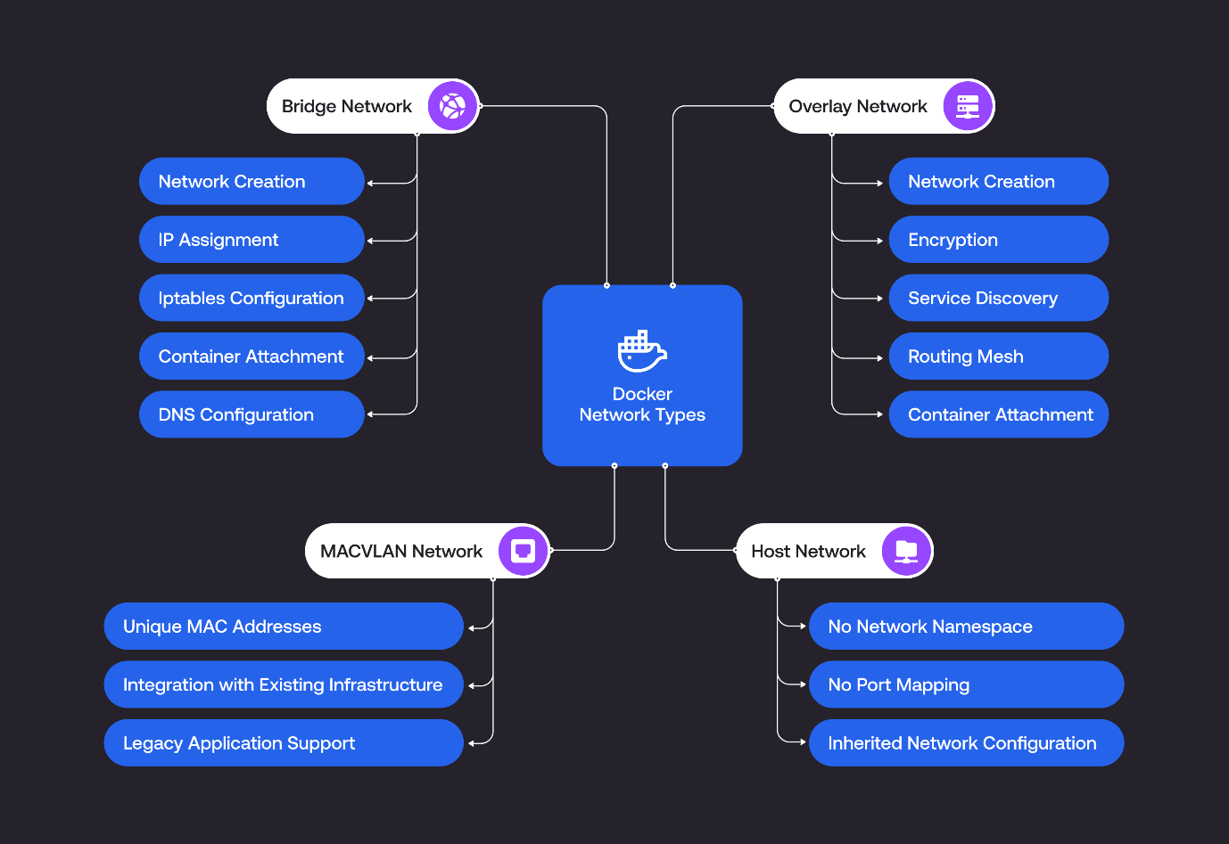
Volumes:
To understand how Docker manages persistent storage through data volumes and bind mounts, we need to explore the role of the Docker Daemon ( dockerd) in handling these storage options. This includes the internal processes that occur when commands related to persistent storage are executed. Docker containers are ephemeral by nature, meaning that any data stored within a container's writable layer is lost when the container is removed. To address this, Docker provides two primary mechanisms for persistent storage: data volumes and bind mounts. Choosing between data volumes and bind mounts depends on your specific needs. Data volumes can be used for better management and isolation, and bind mounts can be used for direct access to the host filesystem.
Data volumes
These are stored in a part of the host filesystem managed by Docker, typically under /var/lib/docker/volumes/. They are designed to persist data beyond the lifecycle of a single container and can be shared among multiple containers. The Docker Daemon manages these volumes, ensuring data integrity and isolation.
Creating a Data Volume
When you execute the following command:
docker volume create my_volume
Here are the things that happen internally
- Command Reception: The Docker client sends the request to the Docker Daemon to create a new volume.
- Volume Creation: The Daemon creates a new directory for the volume under /var/lib/docker/volumes/my_volume/.
- Metadata Update: The Daemon updates its internal metadata to include the new volume, making it available for use by containers.
- Completion Notification: The Daemon sends a confirmation back to the client that the volume has been created successfully.
Using a Data Volume
To use the created volume in a container, you can run:
docker run -d --name my_container -v my_volume:/data alpine
Here is what happens internally
- Command Reception: The Docker client sends a request to run a new container with the specified volume.
- Volume Attachment: The Daemon checks if my_volume exists and prepares to mount it to the /data directory in the container.
- Container Creation: The Daemon creates the container, setting up the necessary filesystem and network configurations.
- Volume Mounting: The Daemon mounts the volume to the specified path inside the container, allowing the container to read from and write to the volume.
- State Management: The Daemon updates the container's state to "running" and monitors its resource usage.

Bind mounts
You can specify a directory on the host filesystem that is mounted into a container. This gives you direct access to the host's filesystem from within the container. Unlike volumes, bind mounts can be located anywhere on the host filesystem.
Using a Bind Mount
To run a container with a bind mount, you can execute:
docker run -d --name my_container -v /path/on/host:/data alpine
Here are the things that happen internally
- Command Reception: The Docker client sends a request to run a new container with the specified bind mount.
- Path Validation: The Daemon verifies that the specified path (/path/on/host) exists on the host filesystem.
- Container Creation: The Daemon creates the container, setting up the necessary filesystem and network configurations.
- Bind Mounting: The Daemon mounts the host directory to the specified path inside the container. Any changes made in that directory inside the container will reflect on the host and vice versa.
- State Management: The Daemon updates the container's state to "running" and monitors its resource usage.

Now that we understand the internal processes involved in using bind mounts, it's important to note that Docker recommends using data volumes over bind mounts for several reasons like:
- Data Management: Data volumes are managed by Docker, which simplifies the management process. They are stored in a specific location on the host filesystem (typically under /var/lib/docker/volumes/), allowing Docker to handle the lifecycle and cleanup of volumes automatically. This reduces the risk of orphaned data and makes it easier to manage storage.
- Isolation: Data volumes provide better isolation from the host filesystem. Since they are not directly tied to a specific directory on the host, they minimize the risk of accidental modification or deletion of important files on the host, enhancing data integrity and security.
- Performance: Data volumes often provide better performance compared to bind mounts. They are optimized for Docker's storage drivers, which can lead to improved read and write speeds, especially when dealing with large amounts of data or high I/O operations.
- Sharing Data: Data volumes can be easily shared among multiple containers, allowing for seamless data access and collaboration between different services. This is particularly useful in microservices architectures where multiple containers need to access the same data.
- Backup and Restore: Backing up and restoring data volumes is straightforward with Docker commands. You can easily create backups of volumes without needing to worry about the underlying host filesystem structure, making data recovery simpler and more efficient.
- Portability: Data volumes can be easily moved or copied between different Docker hosts using Docker commands, making it easier to migrate applications and their data across environments.
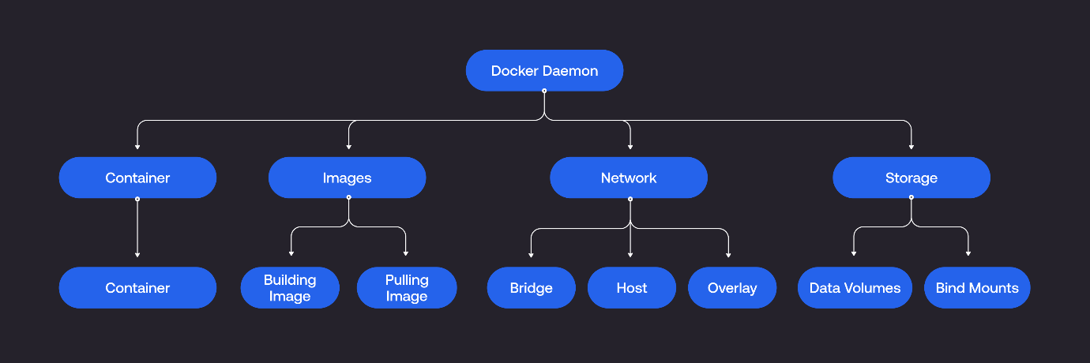
Architecture of Docker
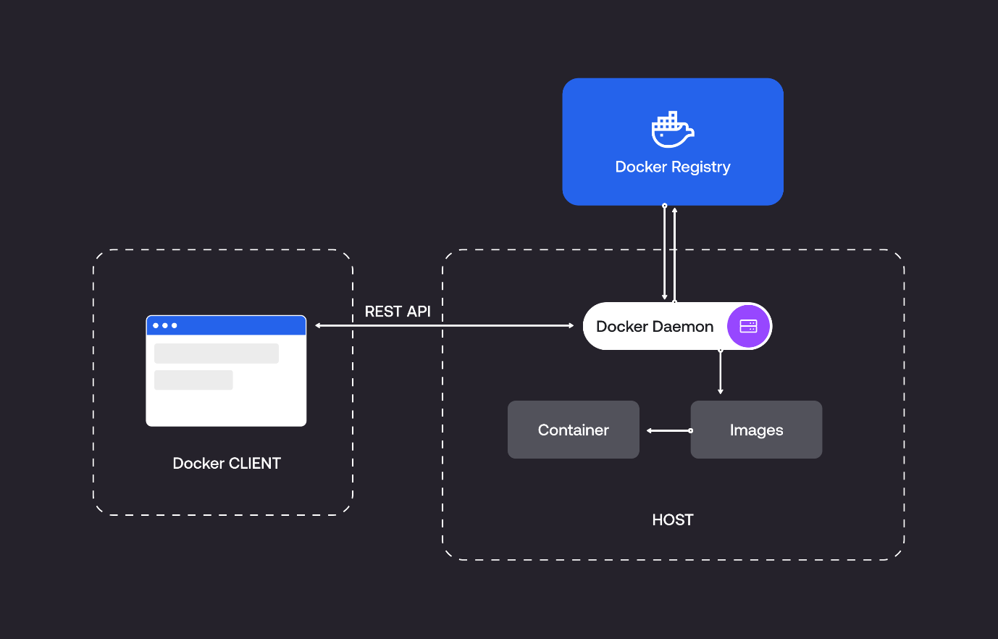
Main Docker components.
Docker Client.
Docker users can interact with Docker through a client. When any docker commands runs, the client sends them to dockerd daemon, which carries them out. Docker API is used by Docker commands. Docker client can communicate with more than one daemon.
The main objective of the docker client is to provide a way to direct the pull of images from the docker registry and run them on the docker host. The common commands which are used by clients are docker build, docker pull, and docker run.
Docker Host.
A Docker host is a type of machine that is responsible for running more than one container. It comprises the Docker daemon, Images, Containers, Networks, and Storage.
Docker Daemon: The core engine that manages Docker operations. It resides on the system running the Docker host and can utilize OCI-compliant runtimes like ContainerD and CRI-O for running containers.

Docker Image.
Docker image is read-only file. Every image comes with numerous layers, and every layer depends on the layer below it. The first layer is called the base layer, which contains the base operating system and image. The layer with dependencies will come above this base layer. These layers will have all the necessary instructions in read-only, which will be the Dockerfile. A container can be built using an image and can be shared with different teams in an organization through a private container registry. In case you want to share the same outside the organization, you can use a public registry for the same.
Docker Repository.
A Docker repository is a collection of Docker images that are stored, organized, and shared. Repositories can be public or private, and they can be local or remote.

Docker Registries
It is the location where the Docker images are stored. It can be a public docker registry or a private docker registry. Docker Hub is the default place of docker images, its stores’ public registry. You can also create and run your own private registry.

Docker Volumes
Instead of adding new layers to an image, a better solution to preserve data produced by a running container is using Docker volumes. This helpful tool allows users to save data, share it between containers, and mount it to new ones. Docker volumes are independent of the container life cycle as they are get stored on the host.
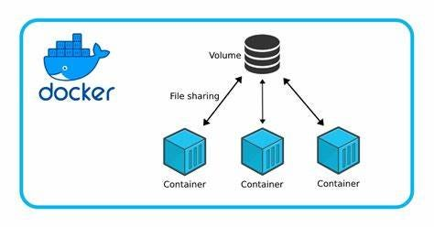

Docker Compose
When running and managing multiple containers simultaneously, Docker Compose is a useful tool designed to simplify the process. It strings multiple containers needed to work together and controls them through a single coordinated command.
Docker Compose is used to launch, execute, communicate, and close containers with a command. This is done using a YAML file which configures the application’s services.
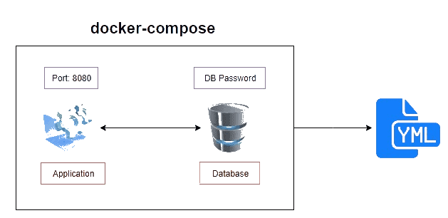

Environment variables:
What is a sense actually of using those environment variables?
Very often, applications require some initial setting parameters like a password or username or some connection details or something else, and you are able to set those values before the start of the application.
For example, let's say that your application needs to connect to some external server and for that it needs to use credentials, username and password, and it is not safe to store this username and password inside of the application files.
It is not safe at all because anyone else may easily read this username and password and use it for his own purposes.
That's why you are able to initialize those parameters, username and password when the application is started, and you can use for that environment variables.
Also, you are able to override any default environment variables if you want to.
-e MYSQL_ROOT_PASSWORD=my-password is an environment variable
Mysql is the container name

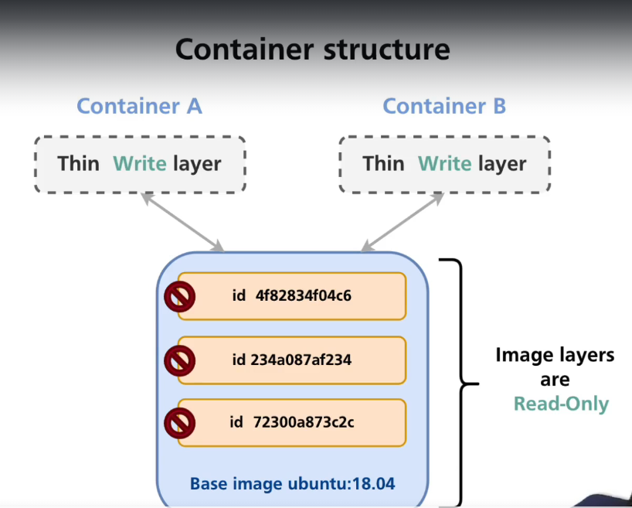

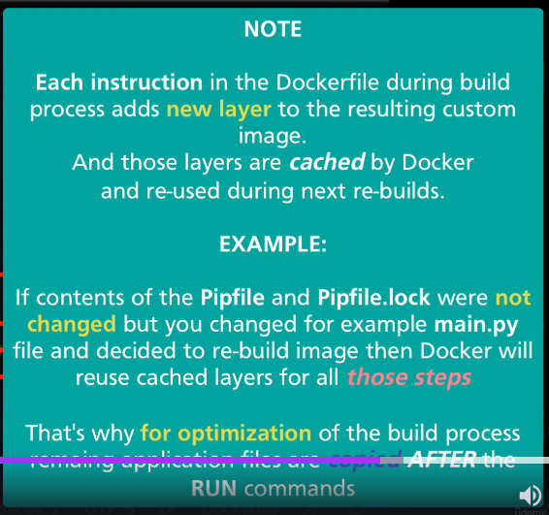
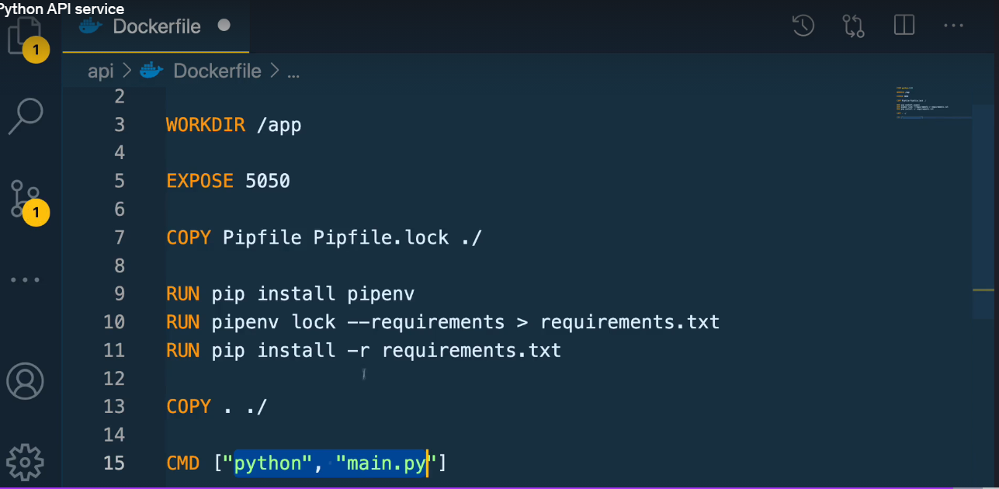
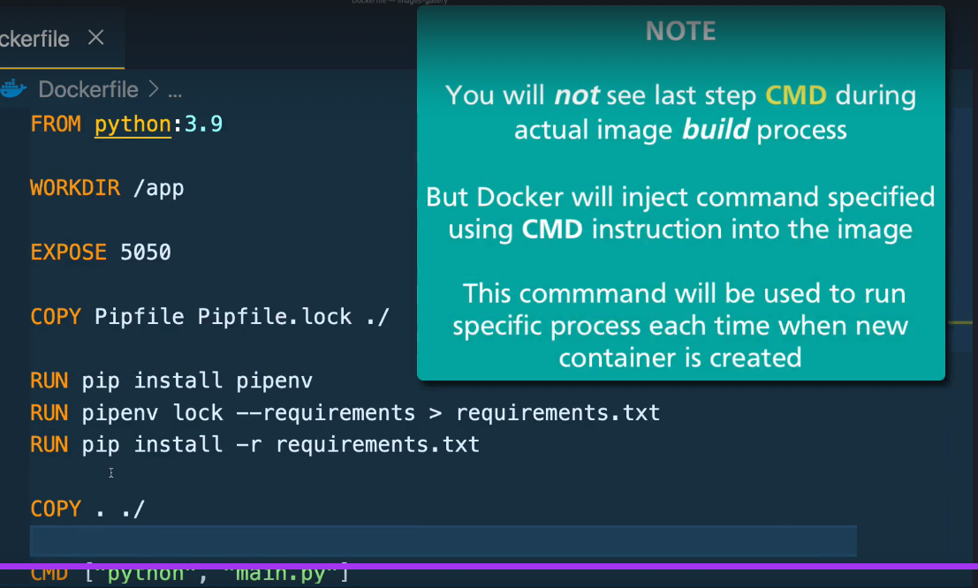
Building docker image:
Checking file inside containter:
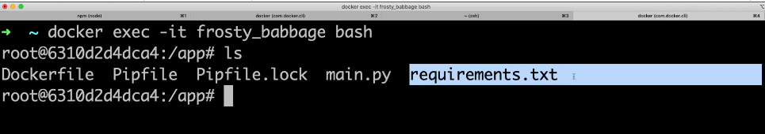
-it -> I means interactive “t” means terminal
To check hidden files or all files below is the command
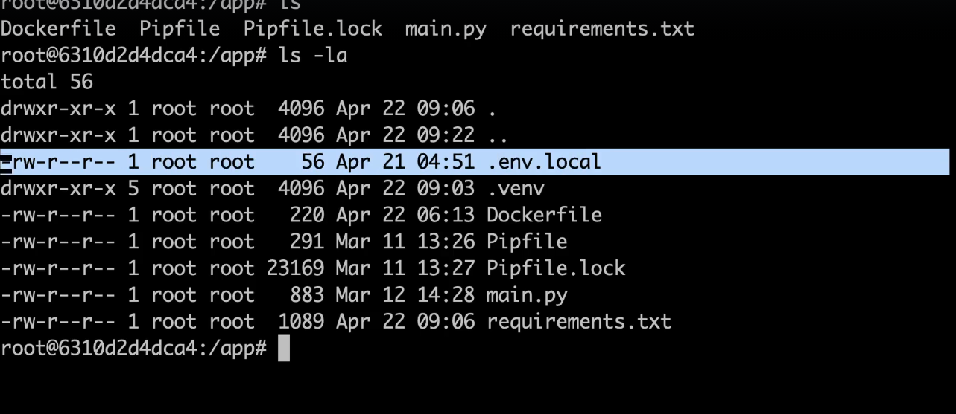


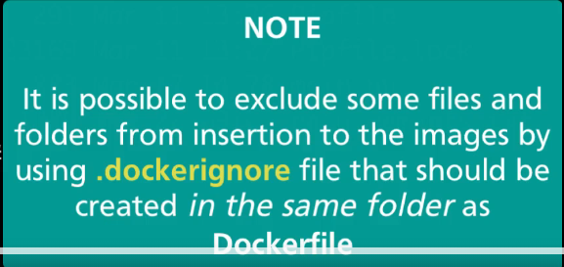
Docker-compose file
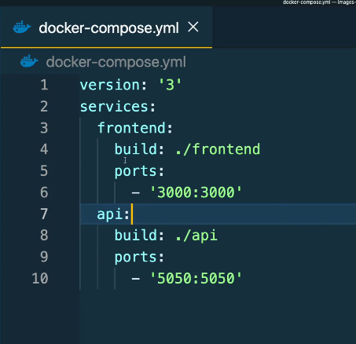

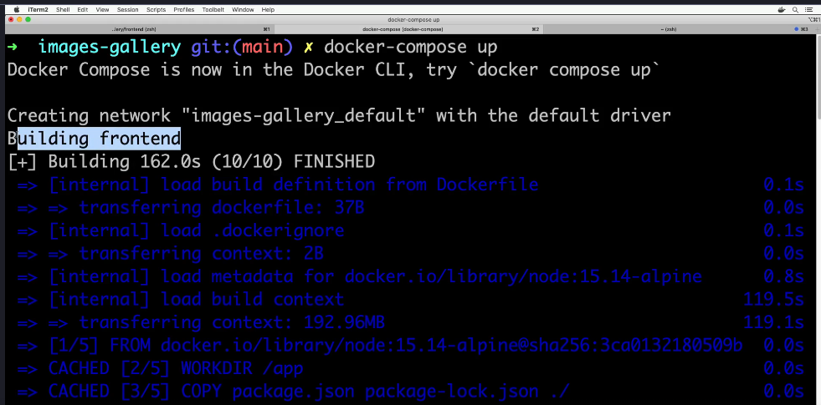
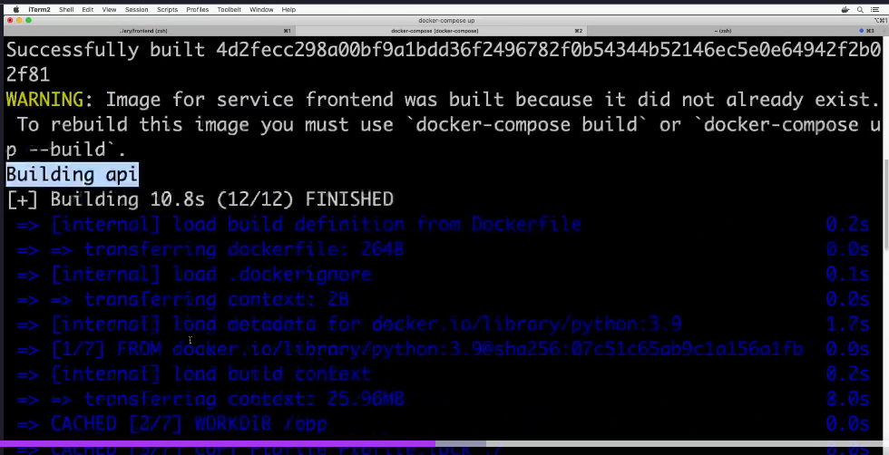
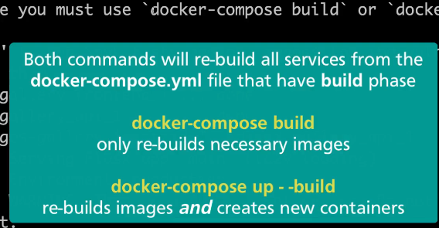

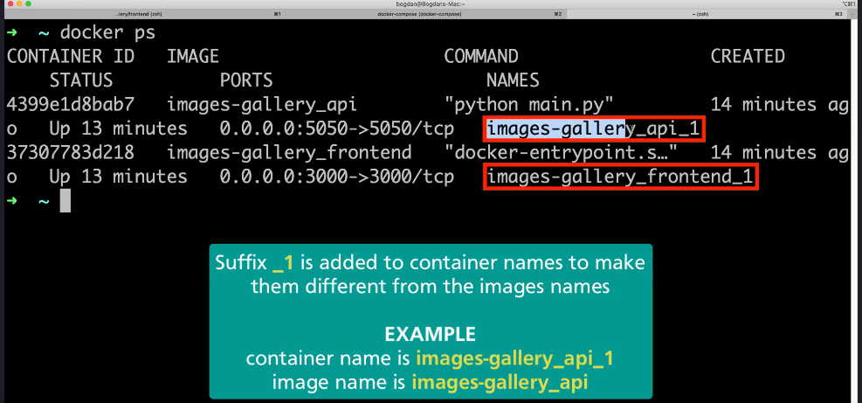

Operate container using Docker-Compose:
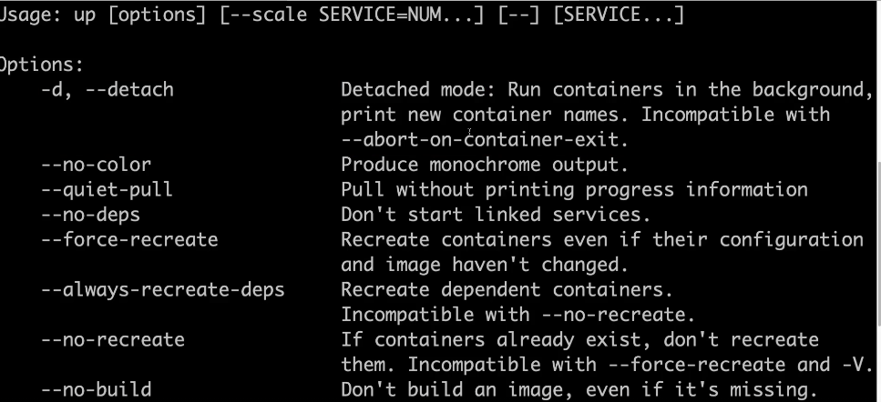
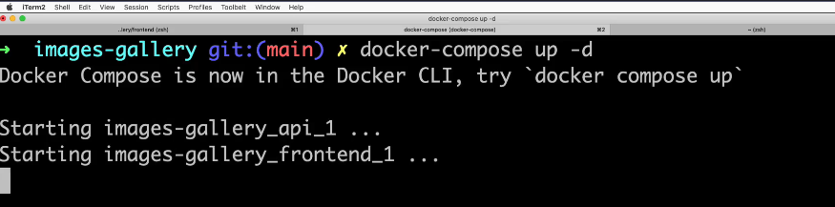
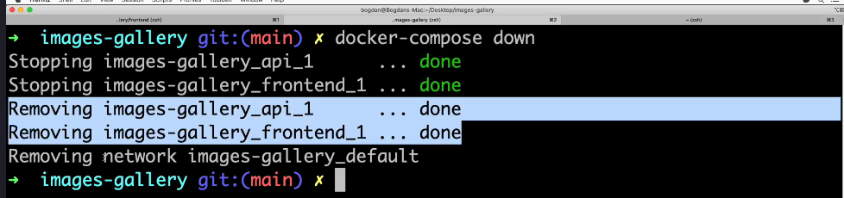

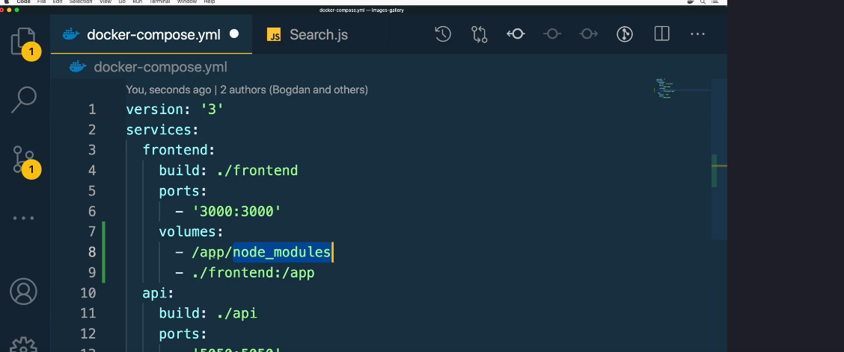
Volume Synce:

Volume sync
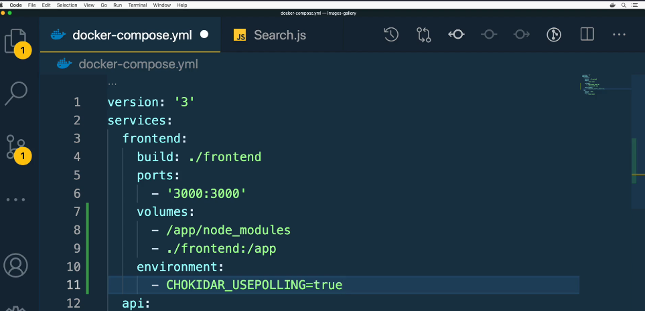

Enable Auto-Restart:
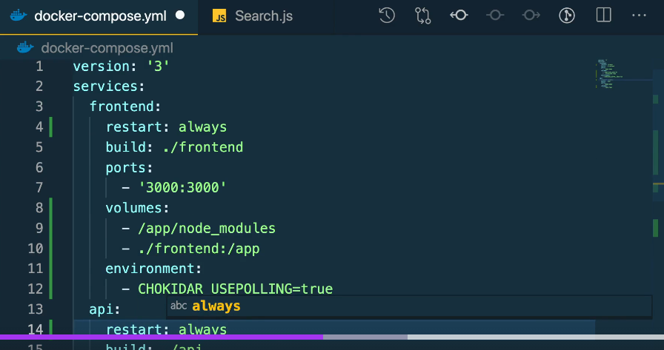

Docker-compose containers communicate with each other:

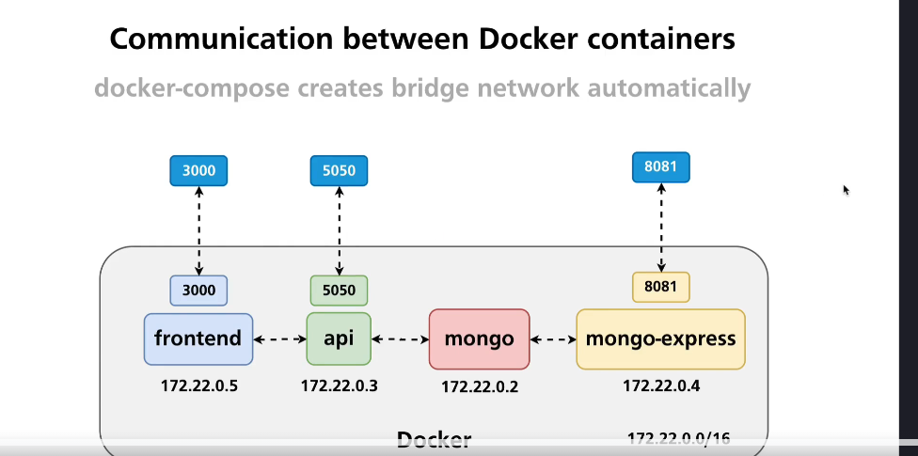
To check IP address of the container, use the command
Docker Networking
hostname -I first container
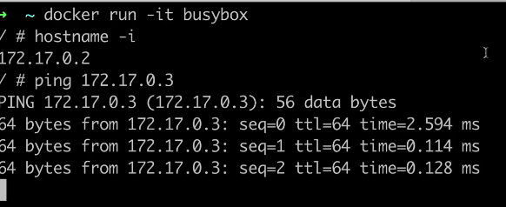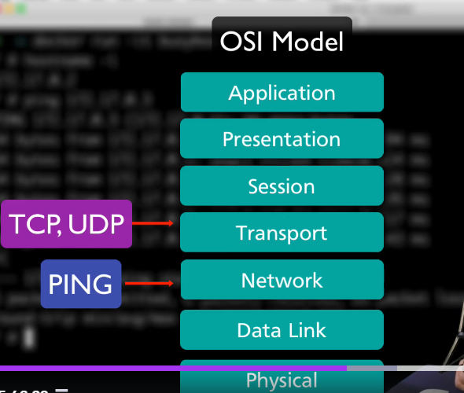
Ping(containers) able to communicate between any TCP,UDP
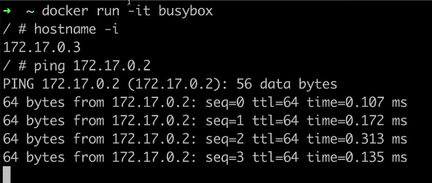
Second container
That's how IP addresses are assigned by default to containers and how we are able to communicate between containers by default in default bridge network.
Also, you can verify which IP address was assigned to the specific container using the command Docker inspect.
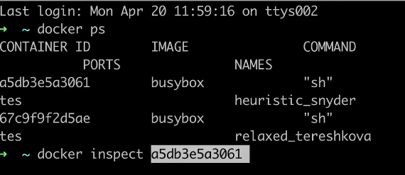
IP address of first container
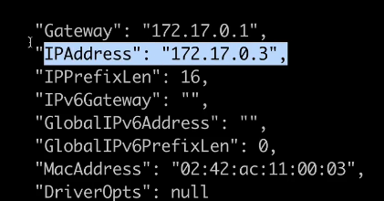
IP Address of second container
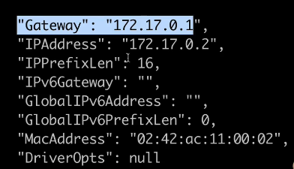

We may also notice that there is a gateway setting, and it is equal for both containers. It is a virtual IP address located at the Docker host and acts as a default gateway for all containers running in the default bridge network.

We can connect to any IP address or hostname on the internet from a container, and for that, we could use the same command ping and, for example, type ping, google.com.
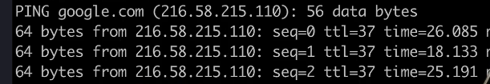
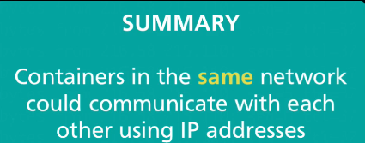
Its not a good idea to communicate between the containers using the IP address because the IP address is dynamic in containers.
If we try to communicate between the containers using hostname, we won't be able to because, by default, docker does not allow communication with hostname in default-bridge. It will allow communication between containers only via IP address.
For communication between the containers via hostname, we have to create a custom bridge and run our containers in that custom bridge
Command to check details of bridge
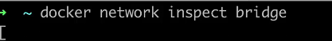

Command to create new network and to check network available in docker
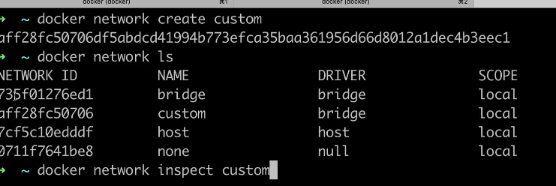
Command to run container inside custom network.
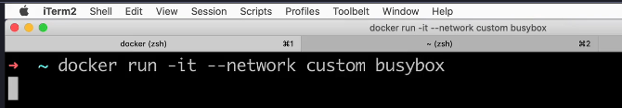
Custom is the name of our custom network and busybox is the name of the container.
“docker run -it –network ourCustomNetworkName imageName”
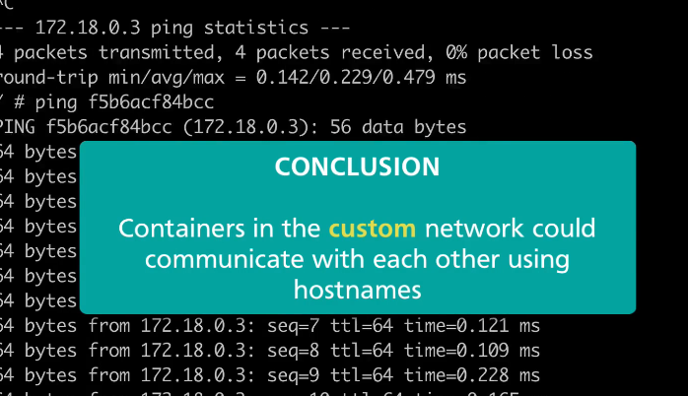
We are able to communicate between the containers with hostname, but hostname is assigned randomly, and they are actually based on ID of specific container.
We also have just verified that we are not able to communicate between containers using names assigned by user.
Creating image with user defined name
First container:
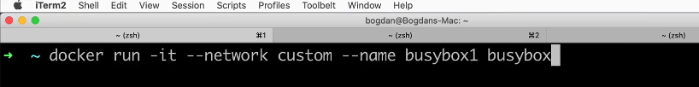
--network custom “custom is the custom network we have created”
--name busybox1 “user defined name for container”
Busybox is the container name.
Second Container
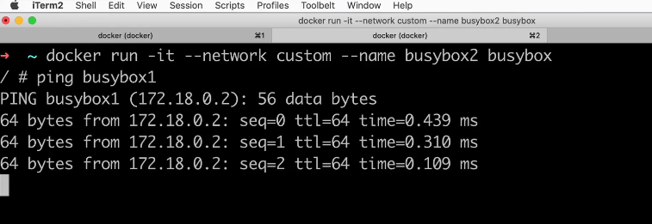
--network custom “custom is the custom network we have created”
--name busybox2 “user defined name for container”
Busybox is the container name.
ping busybox1 “connecting First container with container name”
Kubernetes

